- About the standardised plots and the issue of determining if 95% of the mass is inside [-2,2]. Below you can see two comments on this by Nicky. You decide what to accommodate about her suggestions (she makes a few of them, so whatever you think is the best) and I am happy to then go with it.

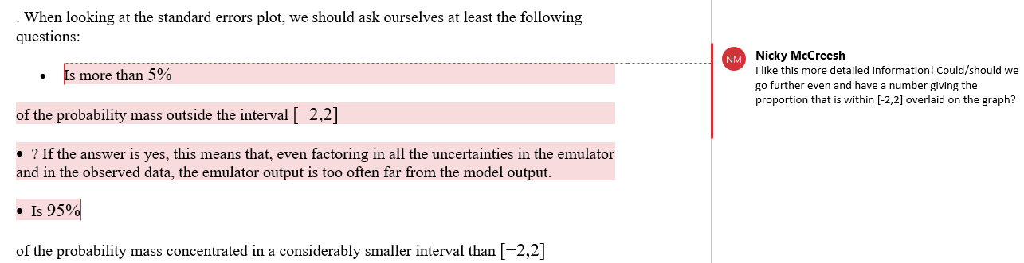

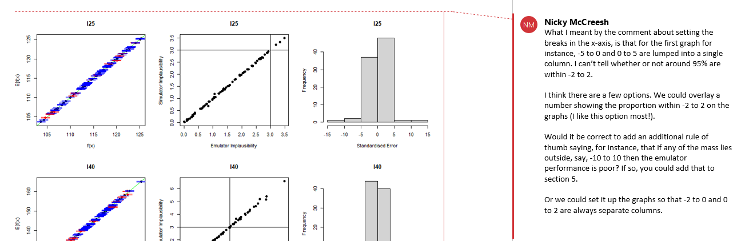

- Nicky asked why aren’t we training the emulators for wave 2 on the non-implausible space of wave 1 by default? Her point is that I mention at the end of wave 2 that one can do that in order to enhance the performance of emulators. But if there are no downsides to doing that, why don’t we do it all the time? My point is that for this SEIRS workshop I tried and it made no difference, so why complicating the tutorial if that’s not needed? But her point is more general: how do I justify that training ems on non-imp space only is not done by default?

- Here I think she refers to the vertical lines and she suggests to make them grey to make it easier to read.
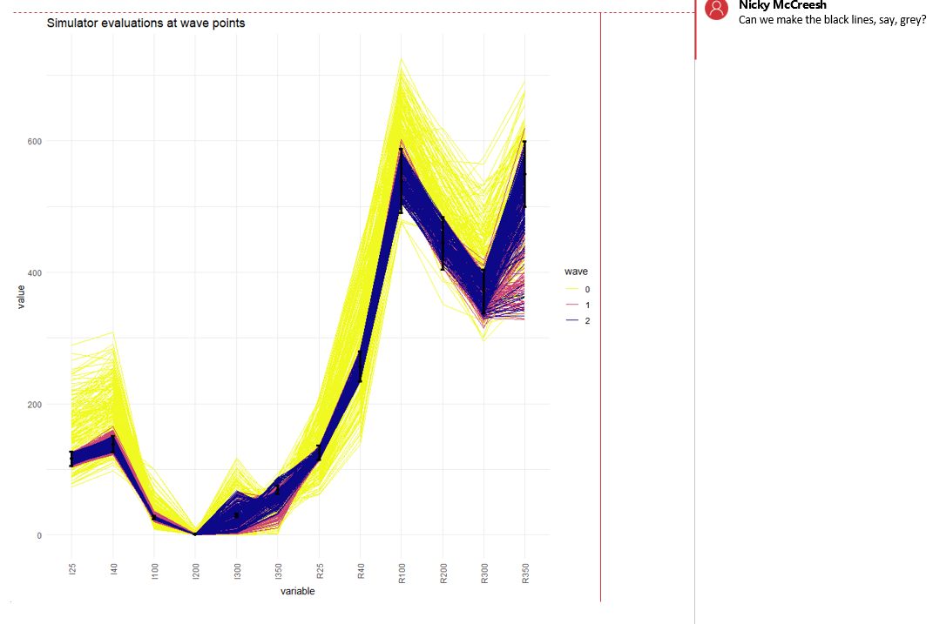

- Below she is asking to explain when the log-scale could be useful. Any ideas?
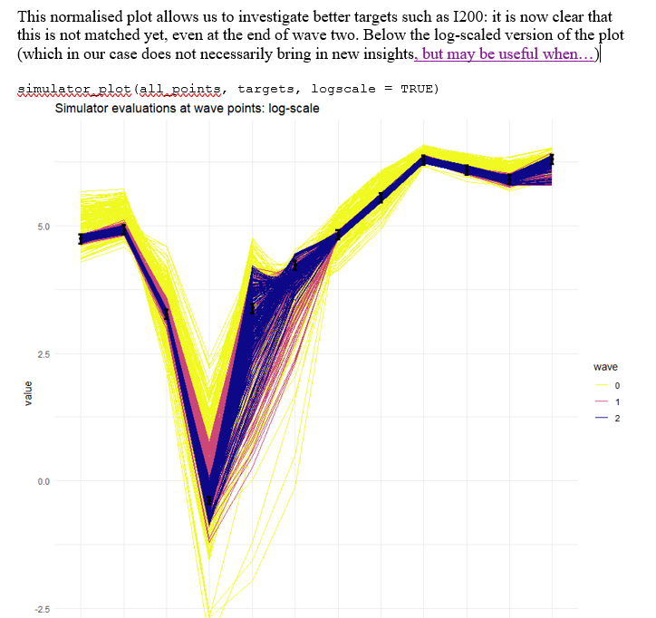

- In this sentence :
“To show what variables are active for an emulator 'em' you can use the method `active_vars`, typing `em$active_vars`.”
Is the word method correct?

- Another question from Nicky
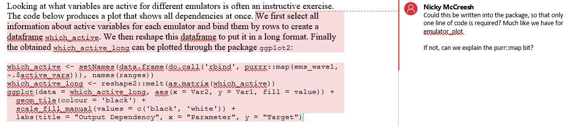

- This goes back to a question you answered some time ago about generating new points, where you said
“ This comes from the way the points are proposed. We've got our LHS proposal, followed by our line sampling. By construction, the line sampling only accepts points that are close to the boundary”
Here (to make sure I understand) when you say that line sampling only accepts points that are close to the boundary, you mean to boundary of the input space, correct?
In the tutorial I wrote
“Pairs of parameter sets are selected at random and more sets are sampled from lines connecting them, with particular importance given to those that are close to the non-implausible boundary.”
But it’s different since I said “non-implausible boundary” and it makes no sense, since we don’t know the non-implausible boundary. We know the boundary of the input space, not where the non-implausible space ends. If this reasoning is correct, I will remove the “non-implausible” and leave just “boundary”.

